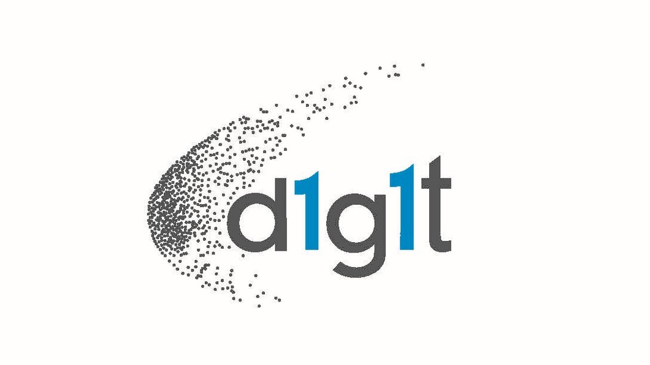

**d1g1t Secures Series A Round to Fund the Growth of its Enterprise Wealth Management Platform**

**CAD $9M investment to support build-out of enterprise portfolio management, analytics and client servicing tools for global wealth management industry**

**TORONTO — November 15, 2018 —** [*d1g1t*](https://www.d1g1t.com/) Inc., the enterprise financial technology company serving the wealth management industry, announced today that it has closed its second round, Series A financing to fund the continued growth of its enterprise digital wealth management platform. Powered by advanced analytics and risk management tools, the *d1g1t* platform offers transparent portfolio management services to professional advisors and their individual investors.

*d1g1t* has raised in excess of CAD $9 million over two private investment rounds lead by [*Purpose Financial*](https://www.purposeinvest.com/), which is headed by Som Seif and backed by the Ontario Municipal Pension Retirement System (OMERS). Other investors in *d1g1t* include highly-regarded Fintech investors Extreme Venture Partners and Portag3, as well as a distinguished group of angel investors and *d1g1t* clients.

Through an innovative cloud-based technology platform, *d1g1t* delivers to financial advisers and their clients greater transparency and enhanced communication that generates trust, as well as an enriched client experience. Its advanced enterprise-wide portfolio and client management capabilities enable advisors to better manage their portfolios and provide their clients with sound investment decision support based on individualized goal-based planning tools, sound risk management and investment analytics.

The [*d1g1t* enterprise wealth management platform](https://www.d1g1t.com/solution/) is now going live with four clients, responsible for managing an approximately CAD $13 billion of assets under management (AUM) for over 5,000 households.

“The wealth management industry has been underserved by modern technology,” said Dr Dan Rosen, co-founder and CEO of *d1g1t*. “We have engineered the *d1g1t* platform to empower advisors to provide proven, transparent, value-added services built around client goals, a richer customized experience for their clients, and stronger client relationships based on long-term trust. Technology, analytics, Big Data and AI will have tremendous impact on the wealth management industry, but will not eliminate the need for human advisors. Instead, they will dramatically improve the services that these advisors provide to their clients.”

The end-to-end platform allows advisors to focus on their client needs and scale the business by uniquely integrating the entire client management lifecycle from client onboarding and financial and investment planning, to portfolio and client monitoring, portfolio rebalancing, trading and compliance.

*d1g1t* is co-founded by veteran Fintech entrepreneurs, [Dan Rosen](https://www.linkedin.com/in/dan-rosen-b2ba0b10/), [Philippe Rouanet](https://www.linkedin.com/in/philipperouanet/) and [Benoit Fleury](https://www.linkedin.com/in/benoit-fleury-0526b43/), who previously co-founded R2 Financial Technologies, (acquired by S&P Capital IQ) and before that were senior executives of Algorithmics Inc. (acquired by IBM). Originally incubated at the prestigious Fields Institute in Toronto, the company has put together one of the strongest financial engineering teams in the industry to build and support the *d1g1t* platform.

[Purpose Financial](https://www.purposeinvest.com/) is both a lead investor in *d1g1t* and a client. Its Purpose Advisory Solutions platform has been working with the *d1g1t* team for the last 12 months, as one of the four early development clients.

“We’re excited to support *d1g1t* in its roadmap as we feel our industry has done little to invest in technology to support advisors and allow them to optimize their portfolio strategies and client experience,” said Som Seif, CEO of Purpose. “*d1g1t* provides an unparalleled end-to-end platform to run a modern advisory business which enables advisors to manage much bigger books more efficiently. Advisors and business leaders can now manage their business real-time through business intelligence and continuity reports, advisors can focus on value added activities, and their families and clients can get full transparency through an integrated client experience and modern reporting.”

To learn more please visit: <https://www.d1g1t.com>.

## About *d1g1t* Inc.

*d1g1t* provides a new digital end-to-end wealth management platform powered by sophisticated analytics and risk management tools that offers transparent portfolio management services to professional advisers and their individual investors. Headquartered in Toronto, the company is founded by an experienced team of financial technology experts who have developed some of the leading portfolio systems for banks, institutional asset managers, hedge funds, pension funds, insurance companies, and regulators around the world.

**Contact**

Michele McDermott-Fox

The Top Floor Public Relations

[michele@thetopflooragency.com](mailto:michele@thetopflooragency.com)

+1.905.379.1893